**Steps followed throughout the task are mentioned below along with snippets:**

* Deployed the resources using terraform
* Used this command to download credentials to connect kubernetes cluster managed by AKS

az aks get-credentials --resource-group aks-cluster-rg --name aks-cluster

* Created a two Dockerfiles; one for php-apache and the other for mysql
* Created an image from these docker files and pushed the same into ACR

Docker build -t (image name):(tag)

az acr login --name (acr-name)

docker push (name of acr).azurecr.io/(image-name):(tag)

* Created kubernetes manifest files for both php-apache and mysql
* Used this command to to create deployments for php-apache

kubectl apply -f (K8 manifest file name)

* Used this command to create kubernetes secrets

kubectl create secret generic mysql-secret --from-literal=MYSQL_ROOT_PASSWORD=root --from-literal=MYSQL_DATABASE=mydatabase --from-literal=MYSQL_USER=myuser --from-literal=MYSQL_PASSWORD=mypassword

* Used this command to to create deployments for mysql

kubectl apply -f (K8 manifest file name)

Below are the snippets

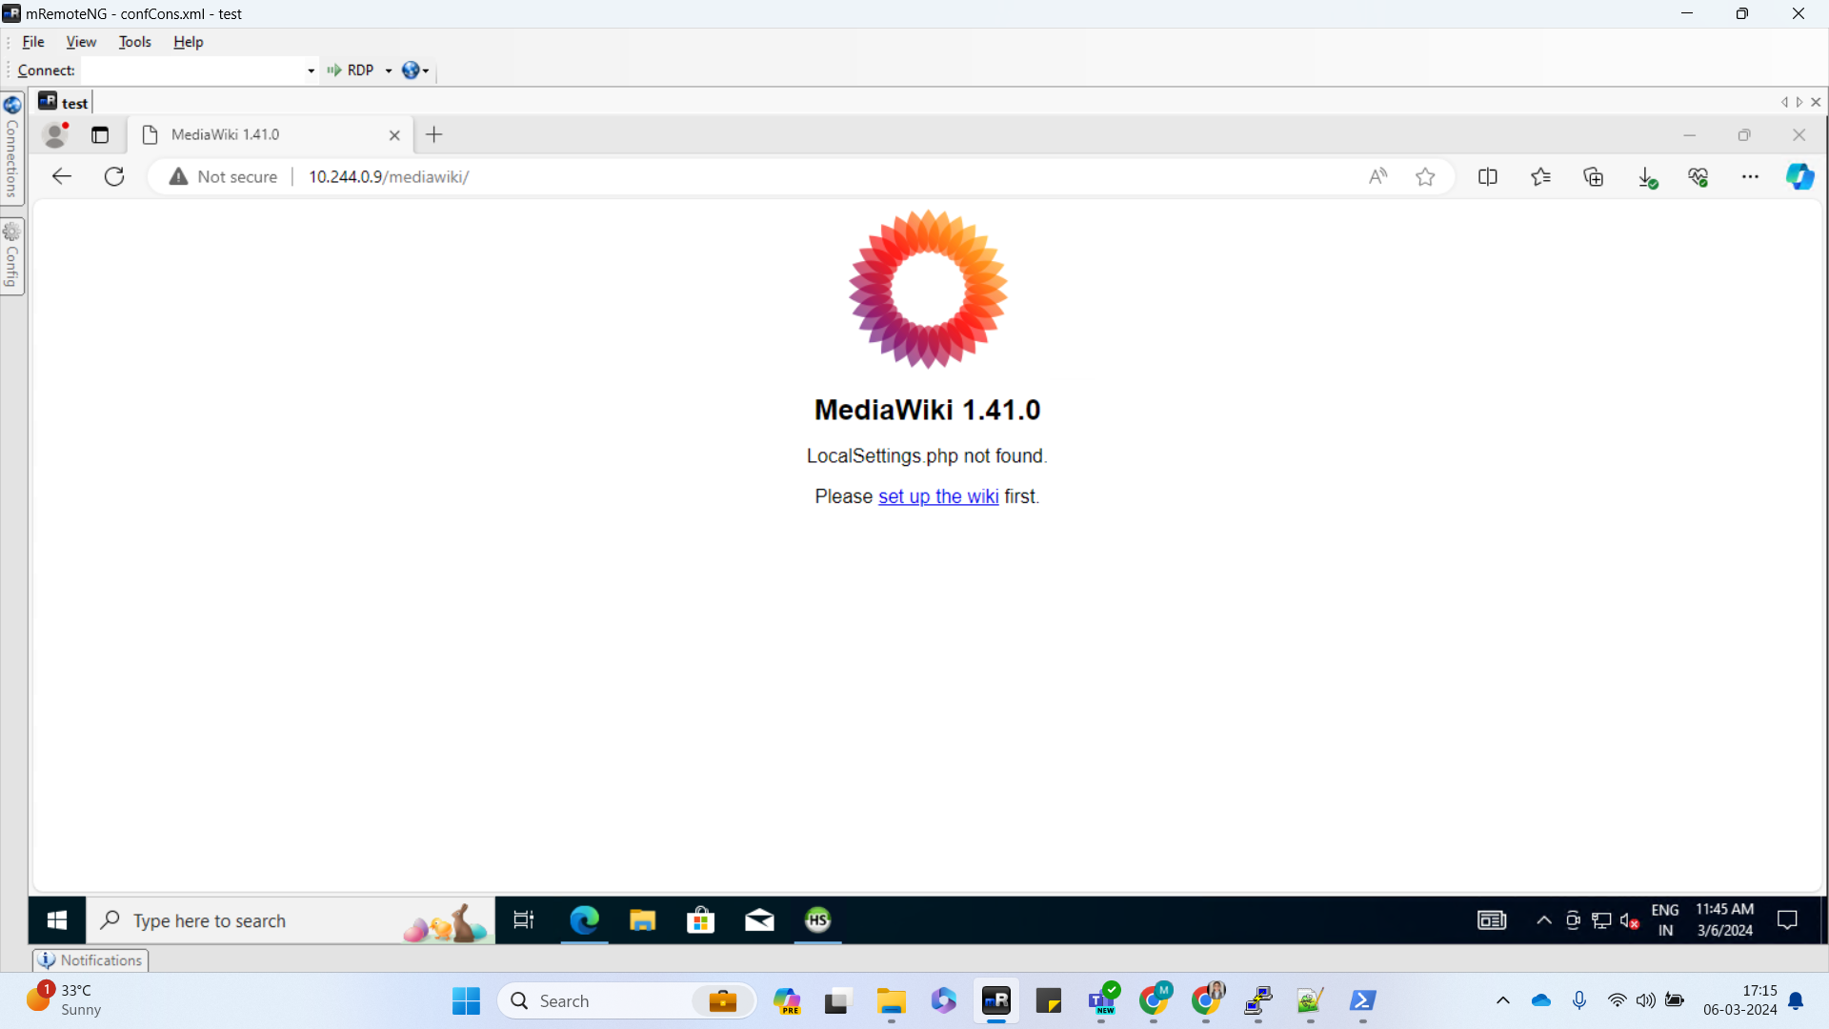

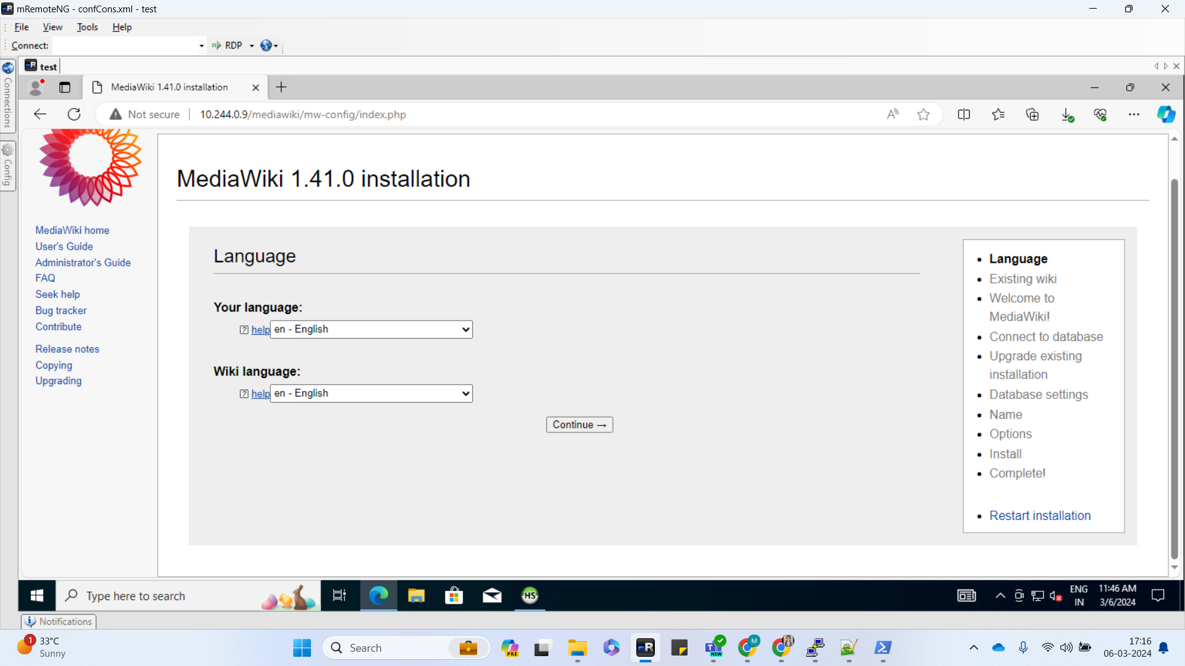

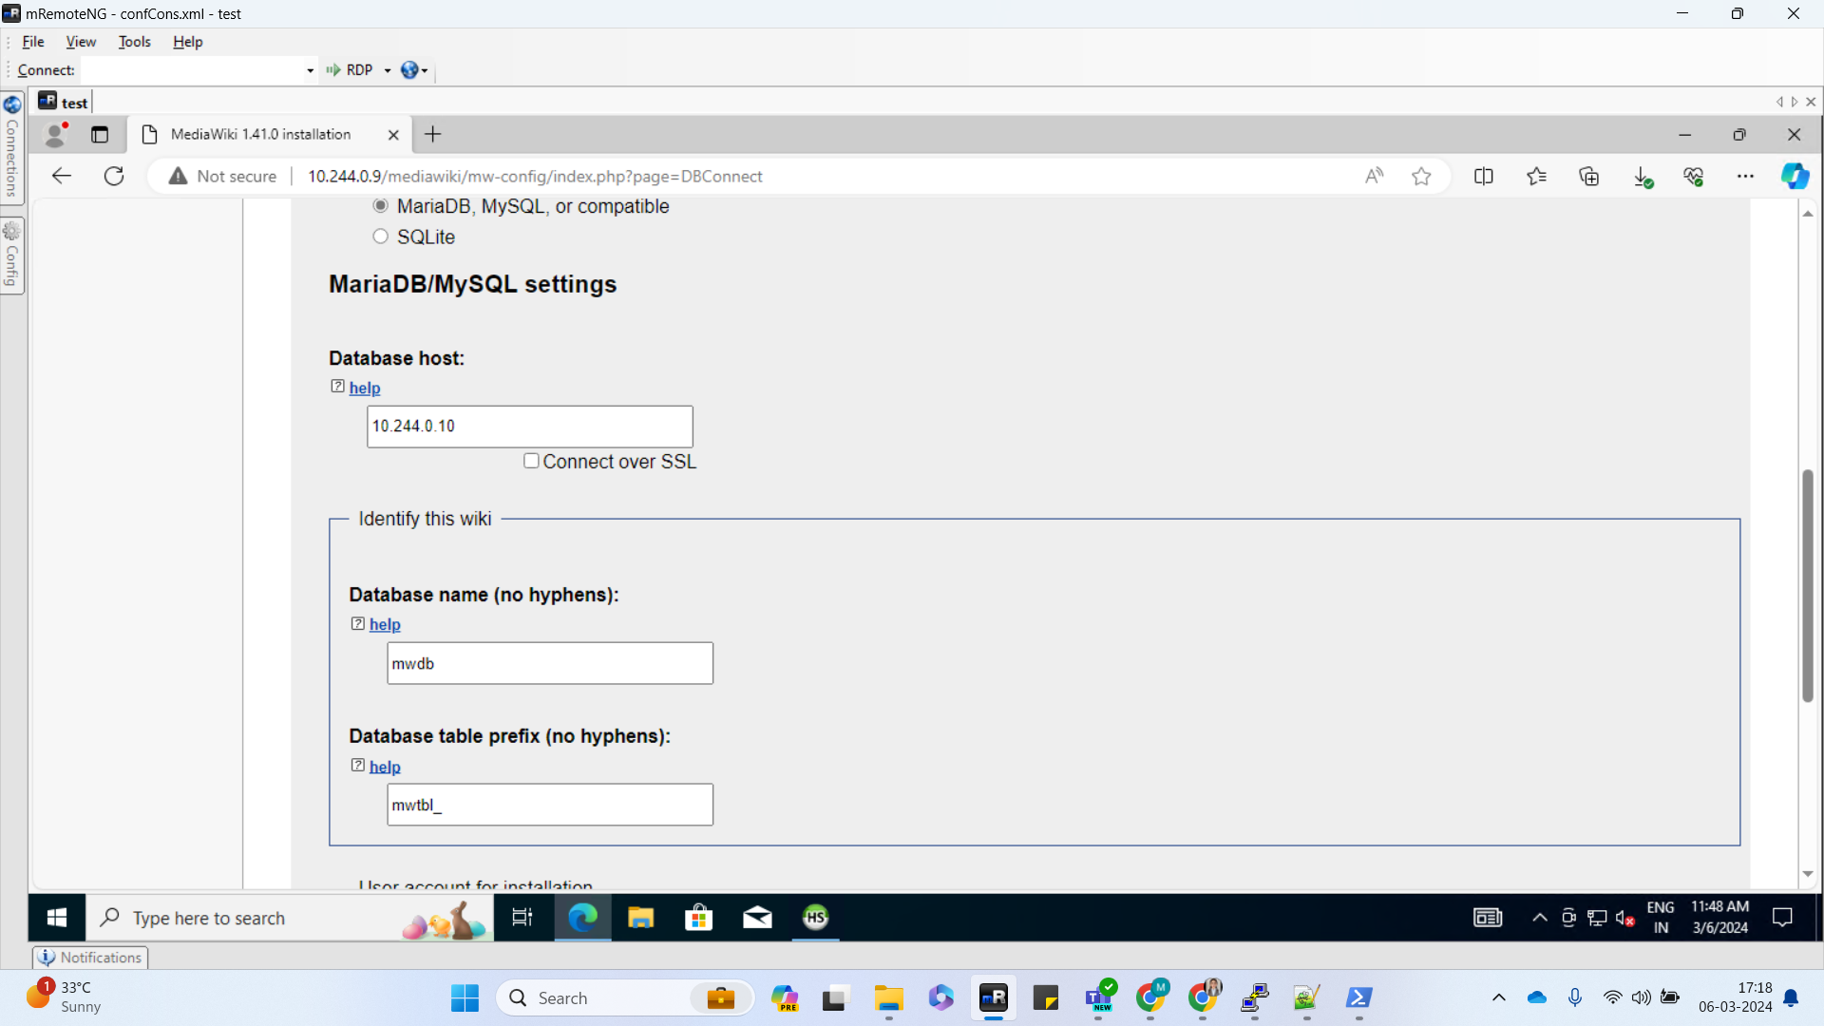

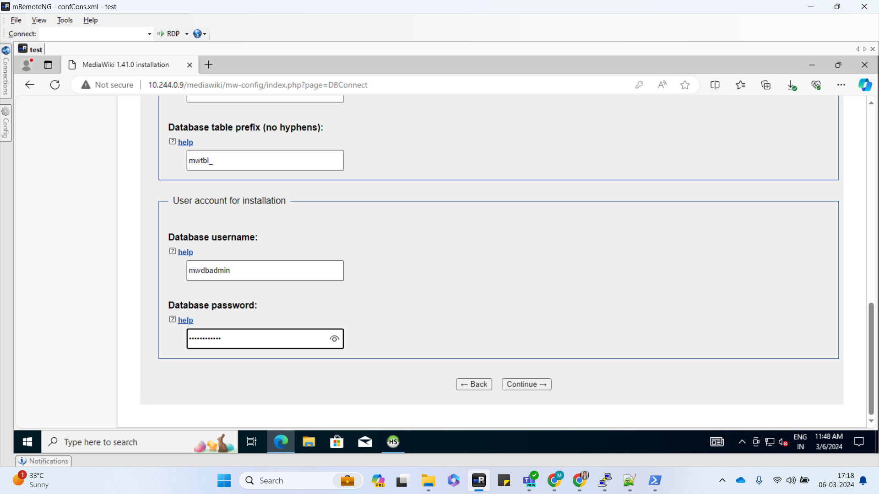

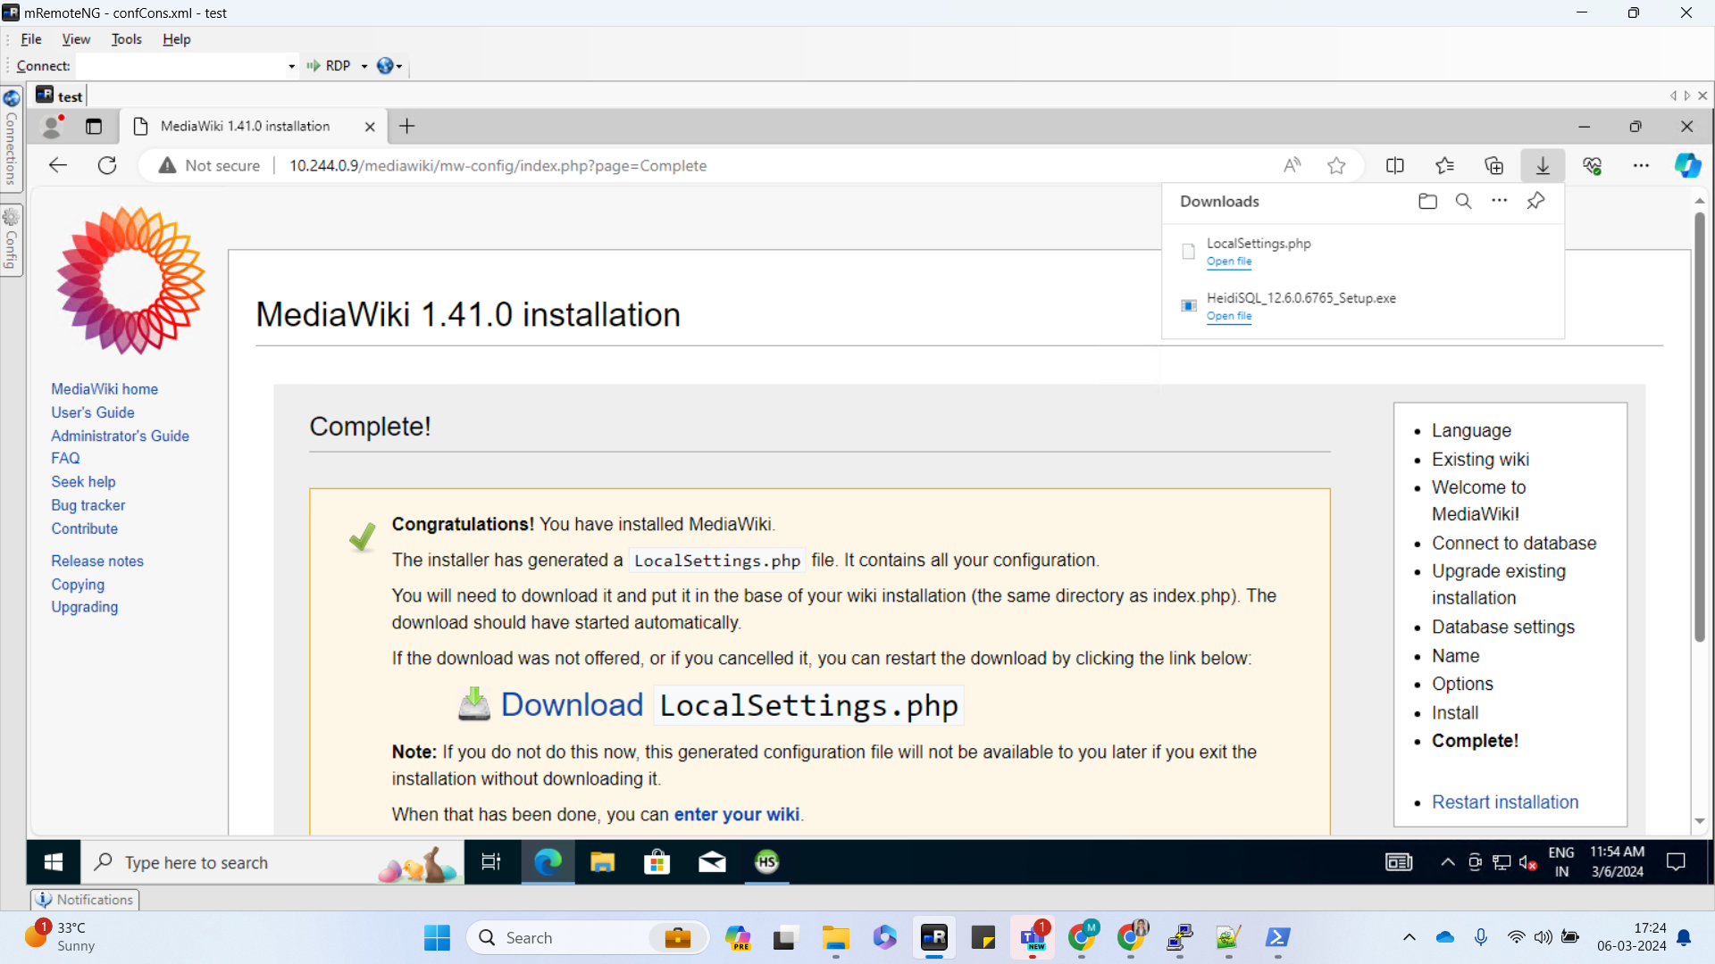

Downloaded the LocalSettings file and pasted it inside php-site pod by using the following command

kubectl cp ./LocalSettings.php default/php-site-8577488dd5-rfqtx:/var/www/html/mediawiki

Below were the results after uploading the file

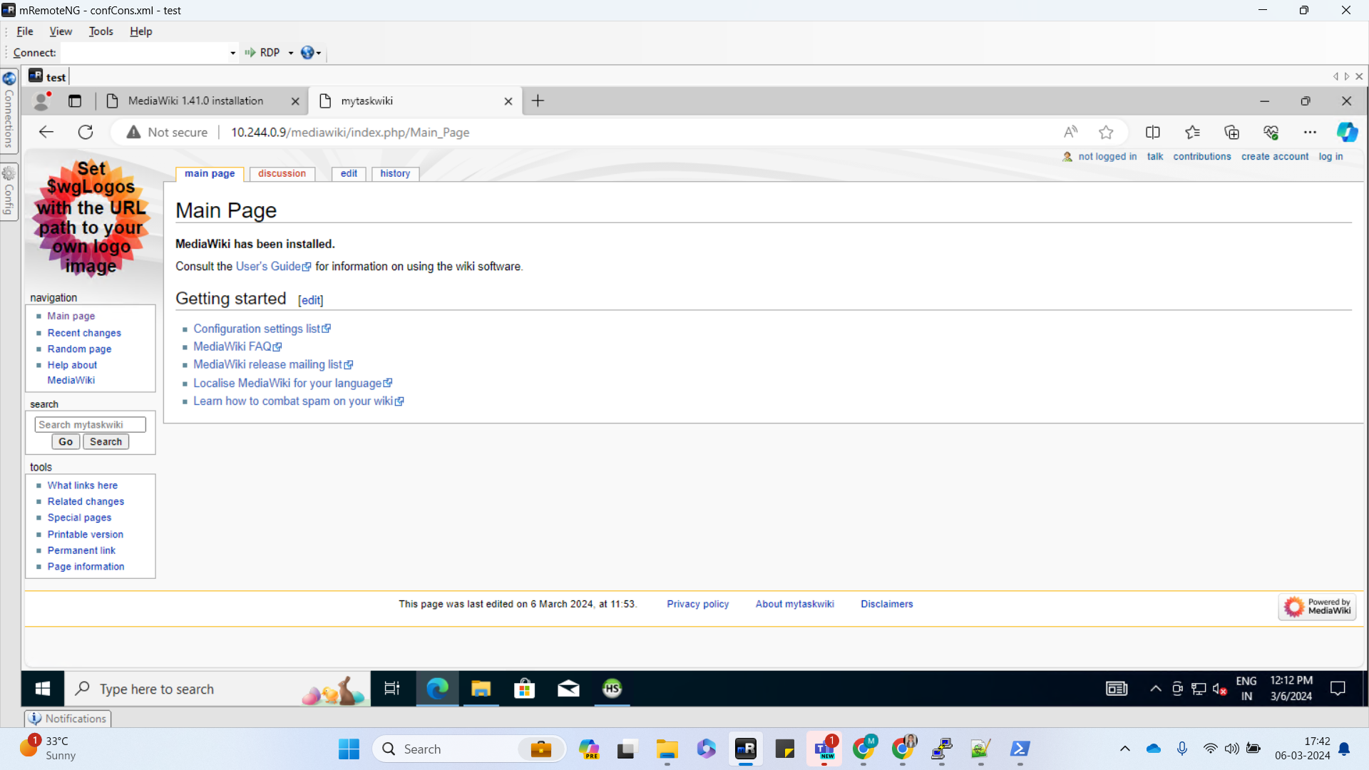

CLI snippet

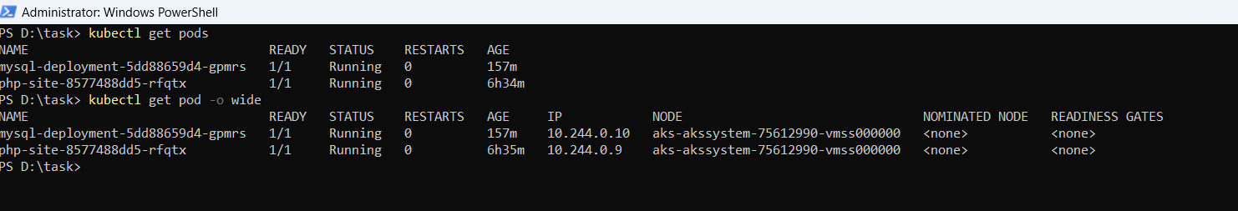

Database connection snippet

